TJ, §§13 and 14

Review
- We have the general idea of the theory: principles will be identified by seeing what fairly situated parties would choose. We have now begun to fill in the details of “fairly situated”. This will occupy us through §25.

  - Saw the argument that formal justice is not sufficient for substantive justice

  - Then turned to Rawls’s two principles of substantive justice:

    - Initial formulation (which I’ve simplified a bit)

      - Each person is to have an equal right to the most extensive scheme of basic liberties compatible with like liberties for all.

      - Social and economic inequalities must be arranged so that they are attached to positions and offices open to all and are to everyone’s advantage.

    - We saw that the italicized principles in the 2nd principle are both ambiguous. Thus there are (at least) four possible interpretations of the principle, hence four possible versions that could be presented in the OP.

      - Natural Liberty = formal equality of opportunity + the principle of efficiency

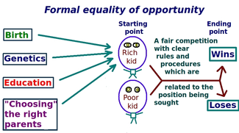
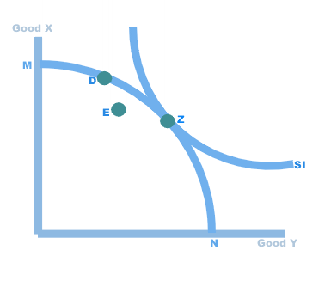

Today
WE’LL RESUME TALKING ABOUT THE PROBLEM WITH NATURAL LIBERTY:

      - Liberal Equality = substantive equality of opportunity + the principle of efficiency

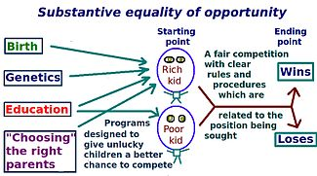

According to substantive equality of opportunity, two people with equal ability and willingness to expend effort will face the same life prospects. (So there should be an arrow from “Genetics” to both “Rich kid” and “Poor kid”). Thus Liberal Equality avoids the problem with Natural Liberty.

BUT suppose Liberal Equality works perfectly. There’s still a problem. What is it? To see the answer, let’s see what problem is solved by a different interpretation of the second priniciple.

      - Natural aristocracy – “an ideal feudal system might try to fulfil the difference principle” (TJ p. 64n12)

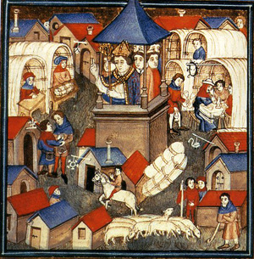

What problem with natural liberty does natural aristocracy solve?
What problem with natural aristocracy does liberal equality solve?

- Why doesn’t Rawls offer these interpretations to the parties in the OP and argue against them there?

- Democratic equality = substantive equality of opportunity + the difference principle

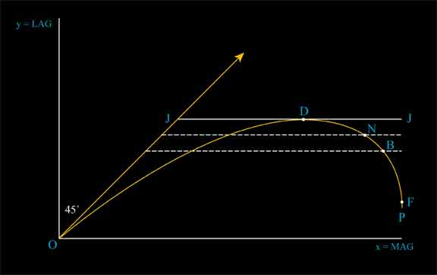

We want to understand the difference principle and see how it enables Democratic Equality to avoid the problem with Natural Liberty.

  - Rawls presents us with graphs showing indifference curves. What points to do they connect – points with equal utility?

  - Now let’s talk about Rawls’s figures 5,6,7 and 8.

    - I couldn’t find those reproduced in Rawls’s order. But I wanted to include some for completeness’ sake. Rawls’s figure 5 is in the middle below. His figure 7 is right-most. Where do we see the left-most?

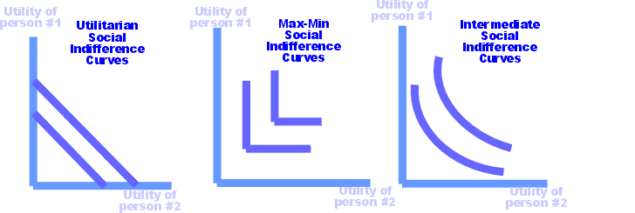

    - Turn to the graphs in the book and talk about them in Rawls’s order:

      - explain the shapes and slopes of the curves in figures 5 and 7.

      - In light of the example Rawls gives at the bottom of p. 67, how would you now state the problem with Liberal Equality? (HINT: In light of the example, what does “ability” mean in Rawls’s definition of fair equality of opportunity?)

      - Now let’s concentrate on figure 6 and 8.

        - What are the horizontal lines in the background of figure 6?

        - What are the sloped lines in the background of figure 8?

        - Distinguish perfectly just, just throughout and unjust. Where are such distributions on the OP curve?

        - Why does Rawls think we should stop at point a? Why does the utilitarian think we should proceed to point b? What would Rawls say about going to point b?

        - How does stopping at point (a) get us the statement of the 2nd principle found on p. 72?

  - In your own words, explain:

    - Chain-connectedness – if an advantage to some representative person raises the expectations of the person in the lowest position, it raises the expectations of everyone in between.

Why does Rawls introduce this assumption? (HINT: What would politics be like if chain-connectedness failed? BIGGER HINT: What is class warfare?)

    - Close-knittedness - it is impossible to raise or lower the expectations of one representative man without raising or lowering the expectations of all the others.

Why does Rawls introduce this assumption? (HINT: What would happen if the curves in figures 6 and 8 went flat to the right of the apex at point (a)?)

  - Explain the important paragraph running from the bottom of p. 72 to the top of p. 73.

- Fair Equality of Opportunity

  - Why implement fair equality of opportunity?

  - Explain perfect, imperfect and pure procedural justice, giving examples of each.

  - Why is it desirable to leave distribution to pure procedural justice? (see p. 76)

  - Is it possible to leave distribution to pure procedural justice? If not -- if a society trying to implement the two principles had to redistribute periodically, say – then would such a society be characterized by another of the three kinds of justice instead? If so, which one?

  - Explain the difference between distributive and allocative justice which is drawn on pp. 76-77.

- The Big Question: Now that we see what Democratic Equality requires, do we find Rawls’s arguments for it and against Natural Liberty and Liberal Equality persuasive? Or is one of those to be preferred?

